Handbook for Action Research as part of WELL
Developing and embedding a research and evidence-based approach to school improvement and professional learning is central to the ambition of Western Excellence in Learning and Leadership (WELL) Action research is a really powerful way to enable collaborative, reflective, problem-solving approaches to address carefully diagnosed priorities, and to improve classroom practice. Our participating schools are learning organisations, continuously striving to be better for the children and young people, including the disadvantaged and vulnerable. In doing so, we utilise existing evidence and we also try new things. We seek to learn from this work, and to adopt, embed and share the practices that work best. One of real strengths of action research is that it takes advantage of rich, local, practitioner knowledge. Through engagement in action research, learning and conclusions take our local context into account and are therefore more likely to indicate if positive changes seen might be suitable to reach across an individual school or, with some intelligent adaptation, more widely across other schools. Through WELL, engagement in quality action research enables the gathering and crucially, the sharing of relevant, rigorous, and rich evidence. The Schools that participated in the Action Research strand in 2021-22 found that this complemented their wider WELL-supported efforts to implement evidence-informed approaches, helping them to identify a baseline picture and to draw out and reflect on emerging implications for their practice and whole school leadership.

This handbook is designed to give you some guidance, support and confidence, in conducting leadership action research in your setting.

It summarises the content of training sessions which have been run for school senior leaders in the West of Cumbria through the WELL (Western Excellence in Leadership of Learning) project, and describes practical steps and tools you can use to inform your action research.

The basics of leadership action research

The purpose of leadership action research
Action Research as a school improvement approach exists to help you:
- identify areas of pedagogy and learning which can be altered to achieve tangible improvement for your setting, and observe and refine those improvements as they unfold
- achieve this, using good quality evidence, both from wider research but also from your own context (and which minimises possible disruption to people’s busy working lives).

In the context of school leadership, it also provides a focus for understanding how you and your colleagues make good use of evidence to monitor developments and plan changes to how things operate.

This handbook describes and explains approaches, tools and systems which can help in achieving these goals. It is important to remember though that the person who knows your context best is you. If you are finding that the systems and tools here don’t seem to be working in your context, then you can and should adapt and refine what is here so the evidence you are working with makes a real contribution to progress; the systems and tools here are guides, not rules.

The core structure of action research
Action research can be broken down into the following steps:
- Setting clear, goals - rooted in evidence (diagnosis)
- Identifying and refining an enquiry question
- Planning evidence collection so that it answers the question, focuses on goals and triangulates evidence (via different perspectives/ sources) and work within the school and the project’s ethical frameworks
- Establishing clarity about starting points (baselining)
- Collecting the evidence you have identified as important
- Analysing evidence against questions/ sub questions and any unforeseen patterns in the evidence to identify results
- Identifying conclusions and implications for next steps
- Repeating cycles of 2, 3, 5, 6 & 7 for formative evaluation
- Creating a poster summarising what you discover and its implications, for sharing with colleagues and for contributing school leaders’ perspectives on research informed leadership to the overall WELL evaluation.

When planning your action research approach, try to develop some clarity about how you will manage each of these steps (supported by this handbook and the tools included within it). You don’t need to have a detailed plan for all of them set in stone at the start, and indeed will probably need to be flexible about some aspects of your plans to accommodate the complexities of school life; you are aiming at being clear about what you will be doing and how it will help for each step in the process.
Each of these layers of activity is described in more detail below and accompanied by short, practical tools for organising/recording your thinking and approach

Setting & clarifying goals for your research and identifying a research question
The first step, and one of the most crucial, in action research is identifying what specifically you are trying to achieve and discover. The overall goals of action research are important but may well be generic or abstract. Making action research effective as a way of improving practice and enhancing learner progress, depends on translating your goals into an enquiry question about leadership; a question capable of shaping your actions at every subsequent stage.

Beginning to frame your research question
The initial process of identifying a research question involves two key elements: identifying and prioritising your school development goals, and identifying potential responses which you want to explore. Which way round you do these is up to you - you might well have a strong idea about an approach you want to adopt, in which case the research question will help you identify what benefits you are hoping it will provide and the evidence you will need to collect to identify and refine its effectiveness.

Alternatively, you might have a strong idea about the teaching, learning or leadership issue you want to address but not a strong sense of how you want to address it. In this case the research question will help you to identify the characteristics your approach will need to have and can therefore help you in choosing an approach to adopt to address it.

Below are some examples of research questions related towel projects to remind you of different ways of framing research questions and the kinds of things they explore:
- “How can using the Great Teaching Toolkit to inform CPD lead to greater teacher effectiveness for our most vulnerable learners?”
- “How can we identify and secure benefits to learner progress & engagement and our teaching & learning approaches at whole school level from participating in the Cumbrian Award?”
- “What aspects of our approach to marking & feedback can be changed to support more effective support for literacy (or, for example, assessment for learning?”
What is your first, instinctive draft question for leadership action research around WELL project work?

Refining your research question
It is very unusual for the first draft of a research question to be the same as the one used throughout the life of an enquiry - they usually need to be refined a few times in the light of challenges and successes encountered on the way. Questions naturally evolve and the evidence you uncover might help you realise that the question you are actually answering is different from the one you originally expected to answer; perhaps tackling the challenge as originally analysed will reveal a different or deeper one?

So do bear in mind that your research question should not be set in stone at the outset and that you should expect to revisit it at a couple of points in your project to check that it remains relevant, and update it if need be. We have identified here some key questions to reflect on when refining your research question:

Is the question specific enough to be researchable, and for the result to be useful?
If your research question is too generic, answering it becomes very difficult in the time you have available. For example, enquiry questions might be concerned with all pedagogy which happens in your setting, or focused on all aspects of learning for all learners instead of for a particular group of learners or area or aspect of learner progress.

When this happens you will find the question doesn’t point you in any particular direction when planning interventions or evidence collection. If you are finding that it’s not clear from your research question what evidence you would need to collect to answer it, or that you need to collect evidence about an unmanageable number of different areas of practice or learning, then consider whether you could make your question more specific.

Is the question open enough for the inquiry process to be worthwhile?
At the other end of the spectrum, your research question might be too narrow. If a research question is too narrow then exploring it is likely to prove trivial or incapable of offering useful broader insights. Research questions which are too narrow, are often closed, or focus too tightly on the needs of a very small and/or specific cohort of learners, too narrow an aspect of practice, or an issue which is naturally time-limited to offer an opportunity for leadership learning and intervention.

Overly narrow questions are generally ones which can be answered very quickly and simply, often with a “yes” or “no”. If you are finding that you or your colleagues are struggling to understand how answering your question will help make meaningful progress for your school development priorities, consider whether you could make it more open and or how you can make more explicit links between an intervention and an aspect of whole school leadership.
What does your leadership action research question look like when you check it for both breadth and specificity?

Can you identify some sub questions?

Establishing an evidence base (baselining)
This section is designed to help you to a) plan what evidence you will collect at the beginning of your action research so you can demonstrate tangible progress across the lifetime of the project, and b) provide you with tools and guidance for understanding what evidence already exists which can help you, (thus minimising disruption). This second point is particularly important for saving you and your colleagues valuable time, so we explore it first.

Building a picture of evidence in your setting
There are two ways of establishing a baseline. For those of you just beginning to explore research and evidence-informed school leadership through your action research there is a tool for identifying in very practical ways how naturally occurring evidence is already used in school and how this could be enhanced. For those of you already working towards research and evidence informed school leadership here is a well developed self assessment tool which can help you take stock of your current stage of development.

A tool for reviewing naturally-occurring evidence
A really valuable starting point for an action research project is reviewing what evidence your school produces routinely (which is relevant to your action research focus - if you don’t know what the focus is going to be yet, then reviewing what naturally-occurring evidence you have might help you identify a focus which is meaningful and which you are well-equipped to explore). This helps you both to understand where you can save yourself and your colleagues time and effort, and where the gaps are which you will need to take additional action to generate evidence.
Which approach looks most useful to you?
- identifying in very practical ways how naturally occurring evidence is already used in school? OR
- Using a research based self-assessment tool to help you take stock of your current stage of development in research informed leadership?

Use of evidence Venn diagram activity
This tool is taken from an evaluation toolkit designed to be used with colleagues in schools, to reflect on their understanding of both what evidence is used in their setting and what it is used for. You can complete it yourselves, work with colleagues to complete it, or do both; complete it yourself and then ask others to complete it and compare the results.

First, create a set of cards or post-its listing the following commonly-used forms of evidence which colleagues encounter in schools. If you are printing these as cards then note the blank ones, for colleagues to describe ones which are more specific to the particular school. Note that some of these may not be relevant in your setting, in which case you can ignore them:
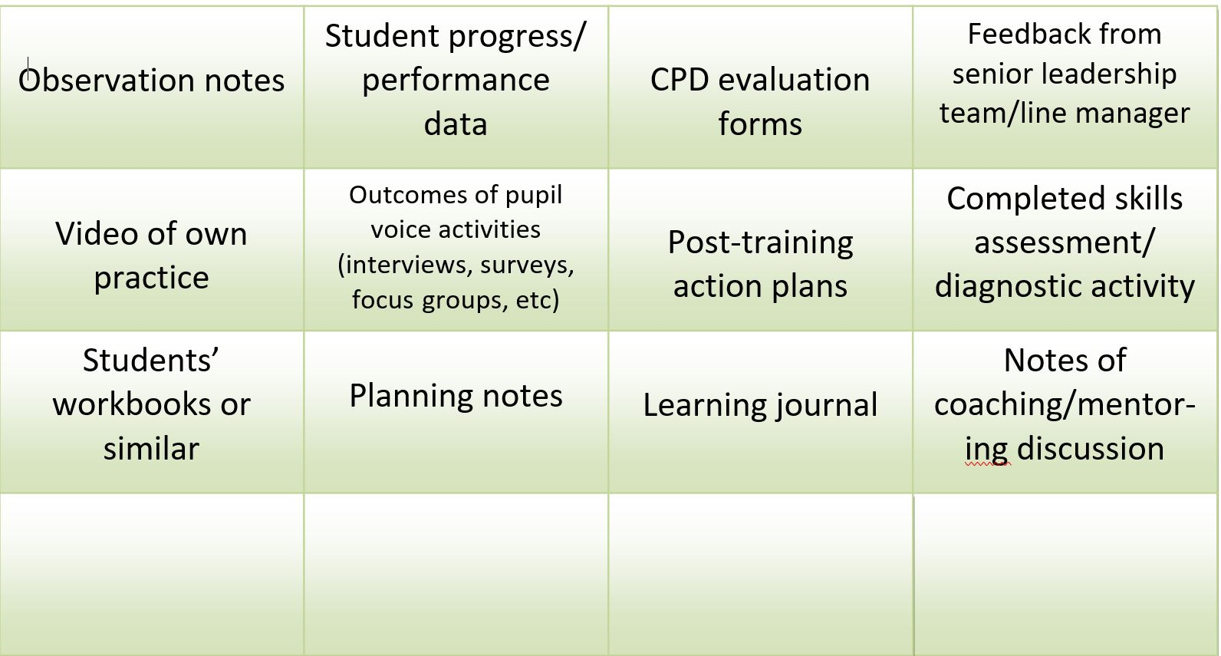

Then, you need a large sheet of flipchart paper or similar, or you can print this out in A3 size - it needs to be large enough to accommodate all or nearly all of your cards in each circle:
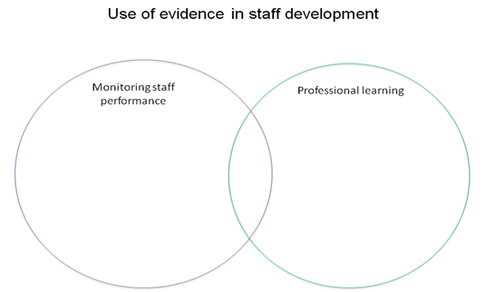

The goal is to identify what purpose each piece of evidence which exists in your school is used for, and how this is understood by colleagues. This information will help you not only in identifying evidence which you can make use of in your action research, but also what it means for colleagues and, potentially, who is best placed to contribute to particular evidence-collection activities you need to organise.

Reflection questions
Answering, or starting to answer, these questions is a useful process for moving from identifying naturally-occurring evidence to using it to inform your action research planning. Once you have started to build a good picture of what evidence your setting generates, try to answer these questions to give you a sense of what it means for your project:
- How does your school approach the purpose and the range of evidence in use?
- How might your school’s approach be refined to enable deeper use of evidence to understand and refine the changes you are making?

Evidence-Informed Teaching: Self-assessment tool
A team of researchers from University-College London, Sheffield Hallam University and Durham University have produced a toolkit for the Chartered College of Teaching, which aims to “help teachers to evaluate and consider their own levels of interaction with evidence in terms of awareness, engagement and use; and illustrate, based on real examples and quotes, what different levels of interaction look like in more or less evidence-informed schools.”

The toolkit is available for free at the URL above, but a couple of particularly relevant sub-sections from it have been produced below as a good starting point.

The first addresses awareness of evidence:
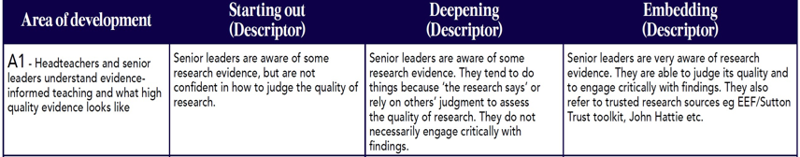

The second addresses engagement with evidence:
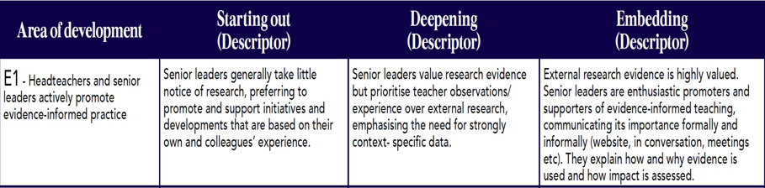

And the third addresses use of evidence: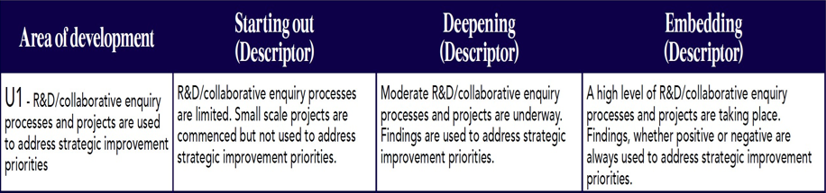

You might find it helpful to take some time with your colleagues to reflect on where you see yourselves as being on these pathways, and what it might look like to try to move to the next stage.

Planning evidence collection
Once you have built a picture of what research or evidence already exists in your setting and or how it is being sued, the next step is to use this to build a plan to bring that evidence into your action research approach, and to identify any gaps which you will need to bridge with other activities in answering your leadership action resrecah question/s. This section of the handbook aims to help you both by providing information about how other leaders in WELL have approached this and through a tool for shaping your thinking around it.

Use of evidence sources from other action research
In the first year of the WELL project, we were able to assemble a detailed picture of the kinds of evidence which colleagues found helpful to support their enquiry. Below we have provided a list of the evidence sources colleagues used, and how widespread their use was across the group:
- Learner assessments and learner voice - for diagnostic, formative, and summative purposes
  - Used by all projects
- Learner work/books (e.g. vocabulary books, floor books)
  - Used by all projects
- SLT monitoring evidence
  - Used by most projects
- Staff meetings, notes of discussions, surveys, coaching conversation, interviews, staff voice
  - The range and intensity of use of this source varied, but was predominantly used for evidence of outcomes
- Parent questionnaires
  - Used by about half the projects
- Teacher and Leadership enquiry tools for focus learners and more extensive use to gauge responses/ confidence changes for whole cohorts
  - Used by a third of projects
- Reviews of documentation (policies, lessons plans, schemes of learning and resources) for new approaches
  - Used by about a third of projects
From the “use of evidence Venn diagram tool” during initial launch sessions, we were also able to build a rich picture of different settings’ starting points in terms of use of evidence at the beginning of the year (from most commonly-used at the top to least-commonly used at the bottom:
- Learner progress (mainly for accountability)
- Learner workbooks (mainly for accountability AND professional development)
- Observation notes (used for both accountability and PD by all who use it)
- Learner voice activities (mainly for both accountability and PD)
- Feedback from SLT (mainly for both accountability and PD)
- CPD evaluation forms (used entirely for PD)
- Notes from coaching/mentoring (mainly for both accountability and PD)
What are your headline reflections on your starting points for this year’s leadership action research about how evidence and research are being used in school? What would you like to enhance?

A tool for creating an outline action research plan from existing research and evidence use
The following table lays out a framework for building an outline plan once you have mapped out the existing available evidence and its uses in your setting. It is designed to be straightforward to use - simply complete the sentence stems with the information you have:

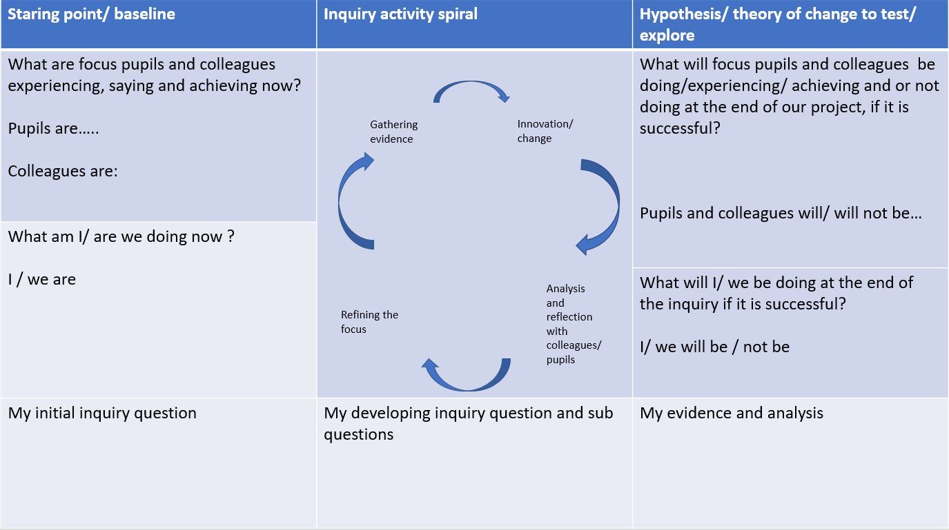

A full size version of this template is included as an appendix at the end of the handbook to make it easier to complete

Cycles of collecting evidence and refining project work
This stage of the handbook will be completed during and after the writing up workshop

Results and Reporting via posters
This stage of the handbook will be completed during and after the writing up workshop

Please see the appendix for a version of the framework for completion.

Appendix A framework for completion

