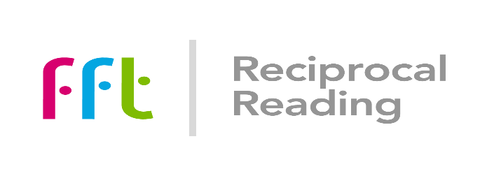

**The *Reading for Learning, Learning to Read* project**

WELL with FFT

The aim of the secondary Reciprocal Reading project with Cumbria WELL (*Reading for Learning, Learning to Read*) is to support students’ reading and understanding and the use of texts across the curriculum, by developing a training and support package – based on Reciprocal Reading - for secondary subject specialist staff who do not normally work in the English or SEN departments.

The intention is that schools should also use this as an opportunity to focus on collaboration and consider the implications of developing and establishing more consistent reading practice in all lessons and in all subjects, where participants on this training act as ambassadors for the new approach, in order to enhance students’ reading comprehension and subject learning.

The training involves, in the first instance:

* One day, face to face training for interested staff from secondary schools
  + At least 2 and ideally 3 subject specialist teachers from each school, from any subject discipline, ideally accompanied by an English or SEN specialist teacher
  + As part of their normal practice, teachers should use texts with their students
  + Colleagues who attend the training should be prepared to act as trail blazers and ambassadors for the project, willing to try out the ideas suggested and, when and where appropriate, disseminate the outcomes and practices to other colleagues in school
* Training will be an adapted version of FFT’s successful reciprocal reading Day 1 training with an emphasis on whole class or large group teaching rather than its use as an intervention.
  + Training will include how to support students with different reading characteristics, skills and level of attainment when reading with them whole class; the importance of consistent reading practice across a school; how to promote comprehension using reciprocal reading techniques as well as opportunities to practise reciprocal reading at an adult level and plan for future subject based reading.
  + This initial training will be in June 2023
  + The project also includes a network meeting to share practice. This will be held ideally before the end of the summer term at a time to be confirmed
  + Schools and colleagues involved can also access support from FFT Advisers should they wish it across the summer and autumn terms 2023
  + Colleagues will be provided with a set of resources to support their work
  + They will be asked to bring copies of subject specific texts with them

This development project, which involves cooperative working between secondary schools, WELL, and FFT, will continue into next academic year, 2023 – 24, with follow up and additional training and resources developed, linked to the outcomes from this first stage of the project.

**The initial training day is planned for June 21st 2023 and will be led by Andy Taylor, Education Director (Literacy) at FFT.**